Reverse Engineering -IRCWARE

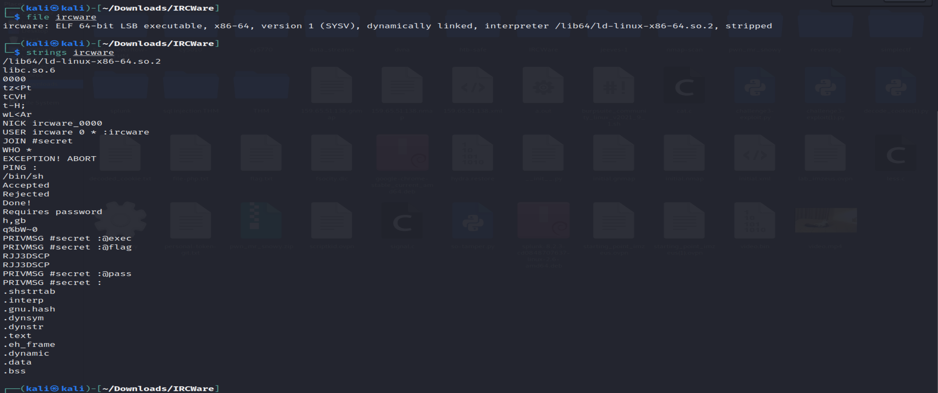

Using ghidra